MR.WASTE

*Save the world*

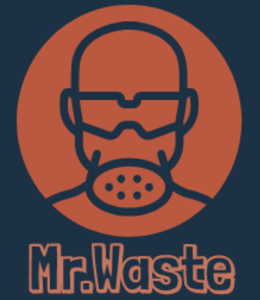

**Project Members**

**Founder:** Abu M Fuad

                                                                               BSC in EEE, AUST

**Researcher & Developer:** Fahmida Ahmed Hridy

                                                           BSC in CSE, BRAC University

**App Developer:** Ehsanul Fahad

                                 BSC in IPE, BUET

                   Shammo

                                  BSC in EEE, AUST

**Web Developer:** Shaugat Ur Rahman

                        BSC in EEE, AUST

INTRODUCTION

The use of plastic items for the COVID 19 epidemic has been increased and people are dumping garbage everywhere due to its negligence. The people who live near beaches used to throw masks and other items directly to sea water. As a result, the environment is polluting and reducing human traffic in the protected areas and other forms of wilderness areas. In this situation we find a solution that, MR.WASTE will collect all these used material that is going to pollute sea water. We will purchase those items from consumers and give it to the waste management companies. We are happy to save the environment and create a workplace for the lower income people.

DURING COVID 19

Due to the current COVID 19 coronavirus, the general population have all taken the precaution to wear surgical masks. When we suddenly have a population of 7.8 billion people wearing one to two masks per day the amount of trash generated is going to be substantial. Those surgical masks are simply a strip of cloth around the faces, today manufactured using non-woven fabrics made from plastics like polypropylene to filter and protect, but this polypropylene does not disappear but rather slowly breaks down into micro plastic which enters food chains with devastating effect. Some environmental groups have found the masks in the countryside or the sea , damaging the environment. These activities have said the masks have intensified the pollution problem world wide. There can be a reduction in erosion and other forms of land degradation or a change in water quality.  Volumes of non-recyclable waste have risen, severe cuts in agricultural and fishery export levels have led to the generation of large quantities of organic waste, maintenance and monitoring of natural ecosystems have been temporarily halted, and tourism activity to natural areas has ceased. As exports of agricultural and fisheries products have declined, production levels have plummeted, causing unemployment levels in both sectors to grow substantially. Also, gloves, masks and other personal protective equipment (PPE) are critical for those fighting the pandemic but are also widely used by the public. Still, because they're not always disposed of properly, environmentalists fear negative consequences for wildlife and marine life and the fight against plastic pollution. According to an article, in marine environments, many animals confuse the plastic littering the oceans for food, including sea turtles. One in three leatherback sea turtles have plastic in their stomach, most often a plastic bag, based on a study of over 370 autopsies. For sea turtles, the plastic blocks their digestive tract and the food that is trapped releases gases that render them buoyant, and unable to dive for food. Estimates suggest that more than 100,000 marine mammals and turtles and over a million seabirds are killed by marine plastic annually. Marine plastic absorbs toxins, which results in it poisoning animals that accidentally ingest it.

PROCEDURE

To avoid the above difficulties, we have come up with a new solution. When your basket is full of the used masks and other items contact us through this app, ‘MR.WASTE’. After using your masks and other items you have to store it in your house and sign up in our app , MR.WASTE, as a consumer. It will find your location and you have to select the waste that you want to give us. Then , the consumer will get money as his list. Using augmented reality , one can scan his items. After scanning items, a notification will go to the delivery person through this app. MR.WASTE will observe the condition of your location and then reach your house to collect it. He will take it away to the waste management company. They will give some money as their raw materials. On the other hand, the waste management companies can also contact us by signing up through our website. Further we will work with all types of waste using the same process.

Here the website link is given below-

[Aplhaoptimus369 – covid-19](https://dev-aplhaoptimus369.pantheonsite.io/?fbclid=IwAR0qDYWUYZVwIQHH8MCmOJIMZy7i5PPuD4IVyQWYnpv1R0wanNKTXgNWp18)

We have developed our app by using NASA’s data.

RESULT

Your waste items will carry onto the waste management company and make our profit. Also this app will create a platform for lower income people where they can work as a delivery person. As plastic materials are the main reason for reducing human traffic in forests, parks, and beaches, there can be a change in the behaviour of land and marine life and perhaps an increase in growth of invasive or harmful species and also have impacts of reduced human traffic in local protected natural environment. So we try to demonstrate the links between reduced human traffic in the natural environment due to covid 19 with positive impacts on existing environmental conditions.